**Fairtrade Impact Report**

**September 2022 to August 2023**

Sales of Fairtrade products have reduced in comparison to last year, despite our best efforts to stock a variety of products and promote them accordingly (Figure 1).

*Figure 1 Sales of Fairtrade products have decreased from last year*

Issues of suppliers moving away from Fairtrade in favour of their own schemes, such as Cadburys, Costa and more recently Starbucks, have made the availability of Fairtrade products more difficult. This is particularly an issue with student accessible pricing being one of our main priorities. We will however, continue to work with our suppliers and purchasing consortiums to try to reverse this trend.

Activities and events have continued to be held throughout the year, to promote Fairtrade.

Fairtrade products were showcased at our Fresher’s Fairs in September 2023, with samples of Fairtrade cookies offered for tasting (Figure 2).

*Figure 2 Fairtrade products showcased at Fresher’s Fairs*

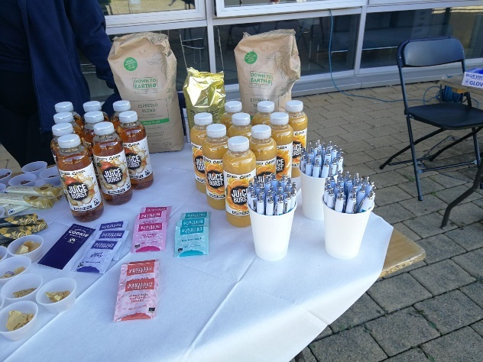 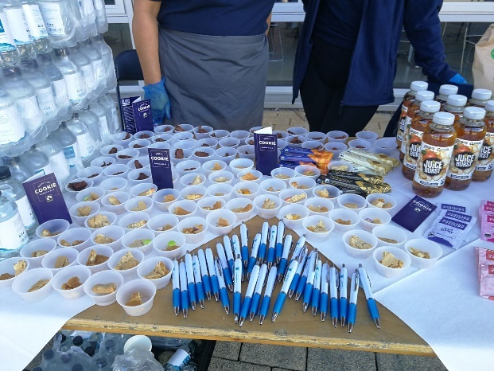

Information on Fairtrade and Fairtrade products were also highlighted on the sustainability stand at Fresher’s Fairs. A hamper of Fairtrade products was offered as a prize for the raffle for students signing up to our sustainability and well-being scheme, Jump (Figure 3).

*Figure 3 Fairtrade products and information on the sustainability stand at Fresher’s Fairs*

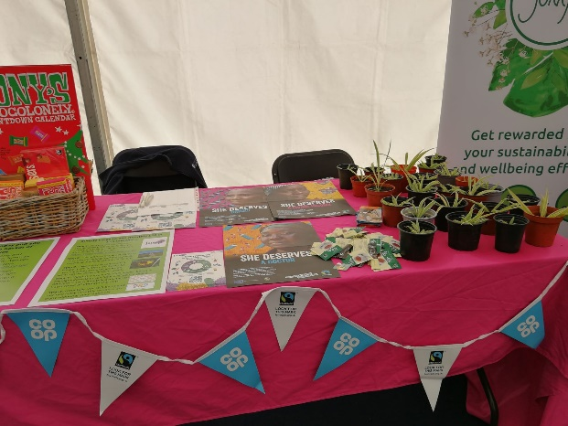 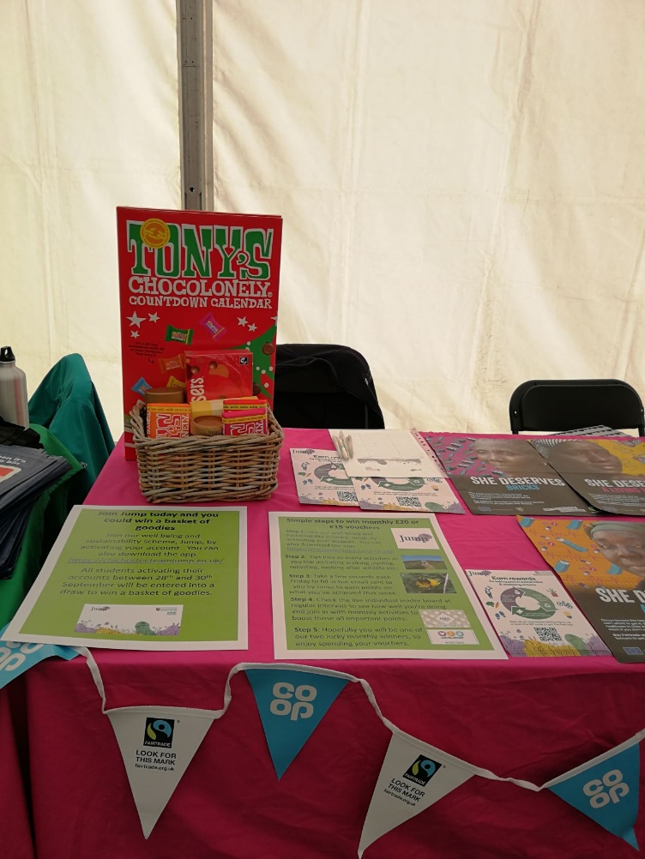

A food fair was also held at our Bishop Otter campus in September 2022. A stand devoted to Fairtrade and local products was included in the fair. Samples of Fairtrade cookies were again offered to participants (Figure 4).

*Figure 4 Fairtrade products showcased at the Food Fair*

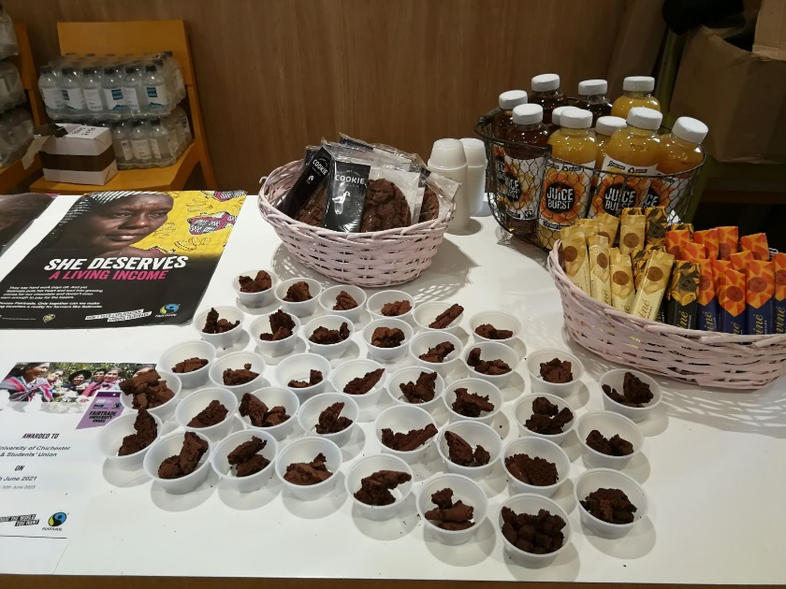

In November 2022, the University and Students’ Union held its annual Green Week.

Green fairs were held at both campuses which were attended by about 100 students and a few members of staff. A stall displaying Fairtrade information was set up at both fairs and attendees were encouraged to take part in a sustainability quiz including many questions on Fairtrade products and the organisation’s aims. Fairtrade chocolate was offered to all as a reward for taking part.

In May 2023, six of our second year event management students organised a Spring Fair with sustainability as its theme, as part of their coursework. One of the stands attracting the most attention on the day was a tombola comprising prizes of everyday items most people need. Fairtrade products such as chocolate were showcased on the stand and Fairtrade wine was offered as one of the most sought after prizes! (Figure 5).

*Figure 5 Fairtrade products showcased at the Spring Fair*

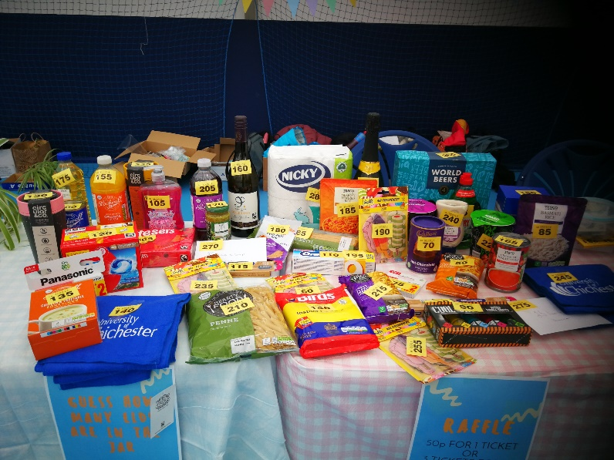 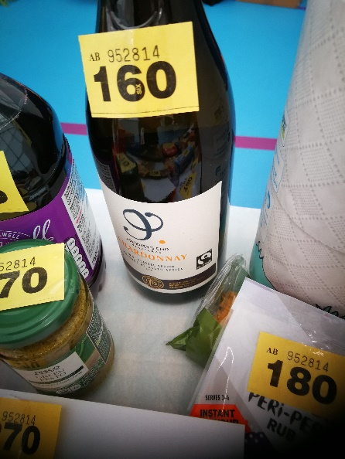

Fairtrade products and activities have continued to be promoted through our Jump scheme. In the last year, 141 Fairtrade purchases have been logged and 1,276 positive food purchases made. This includes Fairtrade and other certified products such as MSC fish, local products, seasonal fruit and vegetables and sustainable products, such as those with no palm oil.

*Figure 6 Fairtrade exhibition*

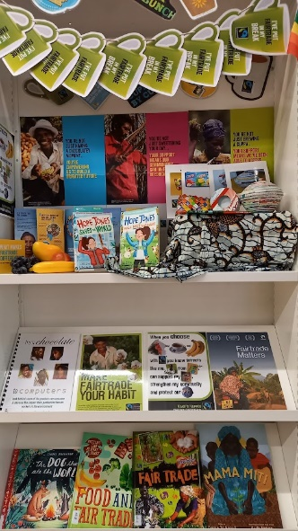These activities were of course in addition to the usual Fairtrade Fortnight events. In order to promote the importance of Fairtrade to farmers producing the products we all love, such as chocolate coffee and cotton, an exhibition was held in the LRC at our Bognor campus. The exhibition, produced by our library staff, included books, leaflets and posters about Fairtrade (Figure 6). A Fairtrade and the climate crisis quiz was hosted on Jump, attracting 35 participants and 11 extra purchases of Fairtrade products were recorded on the Jump platform, throughout the fortnight, with a total of 92 being recorded from October 2022 to February 2023. Our catering contractor ran a promotion on Fairtrade coffee, juice and cookies in our Otters restaurants attracting 15 purchases. A Fairtrade stand was set up on both campuses and students and staff asked questions about their knowledge of Fairtrade and climate concerns. A total of 97 participants engaged with the survey and stand.

The University has continued to liaise with the University of Middlesex and other members of the Fairtrade Network Group to share ideas and best practice. One of the issues discussed again by the group this year was the problem of obtaining Fairtrade products through suppliers affiliated by NUS Services. Other issues discussed were how to engage with students, with suggestions shared through the group, such as enticing them with chocolate!

Progress to all tasks set during the 2022/23 academic year are included on the Action Plan below.

**Fairtrade Action Plan V5 2022-2023**

|  |  |  |  |  |  |  |
| --- | --- | --- | --- | --- | --- | --- |
| **Task and appropriateness** | **Actions** | **Support/budget required** | **Measure of success** | **Responsibility** | **Timescale** | **Task achieved?** |
| Ensure working group continues with BaxterStorey representatives.  Mandatory criteria MN001 | Set up new working group with BaxterStorey, SU and university representatives. | Support required from campus services manager | Quarterly meetings held | Environmental Coordinator | September 2022 to July 2023 | Working group meetings held |
| Use action plan to monitor progress.  Mandatory criteria MN002 | Update action plan and review at working group meetings. | None | Tasks completed in action plan on time. | Environmental Coordinator | September 2022 to July 2023 | Action plan discussed at meetings. |
| Ensure public commitment to support Fairtrade is maintained.  Mandatory criteria MN003 | Update and agree food charter targets for 2022/23 | Support required from BaxterStorey, SU and University | Signed food charter available on website. | Environmental Coordinator | November 2022 | Food charter available on website October 2022. |
| Ensure all students are aware of our Fairtrade status | Include Fairtrade in student’s on-line induction information Required for CI001 | None |  | Environmental Coordinator | September 2022 | Yes – information updated July 2022 |
| Fairtrade products to be used as prizes.  Included as II001 | £5/month | Students continue to engage in sustainability activities. New students win prizes. | Environmental Coordinator | October 2022 to June 2023 | Fairtrade prizes used for Fresher’s Fair and Fairtrade Fortnight. |
| Ensure new staff are aware of our Fairtrade status | Include Fairtrade in staff induction sessions  Required for CI001 | None | Staff induction sessions carried out at least bimonthly | Environmental Coordinator | September 2022 to July 2023 | Fairtrade included in all staff inductions |

|  |  |  |  |  |  |  |
| --- | --- | --- | --- | --- | --- | --- |
| **Task and appropriateness** | **Actions** | **Support/budget required** | **Measure of success** | **Responsibility** | **Timescale** | **Task achieved?** |
| Promote Fairtrade at Fresher's Fair if possible Required for CI010 | Fairtrade stickers and sachets of tea and coffee to be given out to students to highlight that we are a Fairtrade University. | None stickers and products already obtained | Greater than 30 stickers and sachets given out. | Environmental Coordinator | September 2022 | Fairtrade promoted at Freshers Fair |
| Ensure any retail, catering or other commercial outlets stock at least one Fairtrade certified line in at least 2 of the following  • Soft drinks • Wine or Beer • Health & Beauty • Savoury snacks & nuts • Fruit  Mandatory criteria MN007 | Check availability of products offered by BaxterStorey and the SU.  Audit of products available to be produced by Baxterstorey by beginning of November. | Support required from Baxterstorey and the SU | At least one Fairtrade certified line available in The Shop, Otters and the SU bars in at least 2 of the following  • Soft drinks • Wine or Beer • Health & Beauty • Savoury snacks & nuts • Fruit | BaxterStorey  The Shop manager  SU bars manager | August 2023 | Fairtrade soft drinks and fruit stocked in Otters. Problems encountered trying to source Fairtrade savoury snacks now that Propercorn is no longer Fairtrade. |
| Continually increase Fairtrade certified products in retail and catering outlets  Mandatory criteria MN006  Data on sales required for PL003 and PL011. | Ensure Fairtrade certified products in the following categories are stocked in The Shop and catering outlets and work to increase either the number of lines OR number of items sold year on year:   • Tea • Coffee • Sugar • Hot chocolate and cocoa • Chocolate, confectionary or snacks | Data required from BaxterStorey and The Shop Manager | Data provided by the SU and BaxterStorey on the number or sales value of Fairtrade items sold show an increase. | The Shop manager and BaxterStorey | Data to be provided for academic year  2022/23 in September 2023 | Data provided. Sourcing of Fairtrade products at commercially viable prices and in viable quantities has proved problematic. Maltesers sold in SU Shop. |
| **Task and appropriateness** | **Actions** | **Support/budget required** | **Measure of success** | **Responsibility** | **Timescale** | **Task achieved?** |
| Re-introduce some Fairtrade cotton clothing lines for sale on campus  Part of mandatory criteria MN006  Record sales of clothing  Required for PL003 and PL011 | Re-introduce some SU branded clothing in The Shop. Encourage SU societies to use the Fairtrade clothing. Advertise Fairtrade clothing on University and SU websites. |  | Fairtrade branded clothing available in The Shop. | The Shop manager | June 2023 | No - Sourcing of Fairtrade clothing at commercially viable prices has proved problematic. |
| Ensure there is up to date and effective Point of Sale (POS) material in all relevant outlets, highlighting Fairtrade products and providing information on the benefits of Fairtrade to growing communities. Mandatory criteria MN008 | POS material to be displayed in The Shop and catering outlets. This must be placed next to products to avoid confusion, and it should be dated and refreshed periodically. |  | POS material displayed in The Shop and catering outlets with relevant dates. | The Shop manager and BaxterStorey | June 2023 | POS material available on TV screens in Otters and next to products on display. Use of paper “table talkers” has been discontinued as part of our sustainability initiatives. |
| Promote Fairtrade in activities/campaigns outside of Fairtrade Fortnight  Mandatory criteria MN005 | Fairtrade promoted at green fairs during green week. Information provided and stickers, tea and coffee | None | Greater than 20 participants | SU Sustainability Officer and Environmental Coordinator |  | Fairtrade promoted at Green Week fairs at least 100 participants. |
| Fairtrade products and activities promotion on Jump. | Green Rewards | Greater than 10 participants | Environmental Coordinator | Ongoing | Fairtrade activities included on Jump. |
| Fairtrade used as a subject of one of the “bite size sustainability” sessions. | None | At least 3 attendees at presentation | Environmental Coordinator |  | No – only one attendee. |

|  |  |  |  |  |  |  |
| --- | --- | --- | --- | --- | --- | --- |
| **Task and appropriateness** | **Actions** | **Support/budget required** | **Measure of success** | **Responsibility** | **Timescale** | **Task achieved?** |
| Partner with a local off-campus Fairtrade group, and work together on at least one project or campaign over the year.  Required for CI004 |  |  |  |  |  | Not achieved this year. |
| Proactively share one or more learning or best practice examples from their Fairtrade activities with the wider sector  Required for CI009  Included as II002 | Continue to liaise with University of Middlesex and other members of the Fairtrade Network Group to share ideas and best practice. | None | Ideas generated by the group implemented by the University and/or ideas from the University shared with others. | Environmental Coordinator | Ongoing | Yes, ongoing membership of the Fairtrade Network Group |
| Provide and publicise opportunities for students to investigate Fairtrade, trade justice or ethical consumption issues on or off-campus within their course work or dissertations.  Mandatory criteria MN010 | Make opportunities visible and available to students from any discipline to integrate issues of Fairtrade, trade justice or ethical consumption into their coursework. List topics or research questions on website or provide examples of how specific tutors embed these issues into their promotion of project ideas for students to undertake. Publicise opportunities through a variety of channels. | Support required from academic staff.  Use Responsible Futures framework. | At least one piece of coursework or dissertation carried out by a student each academic year. |  | Ongoing | Yes. Student citizenship taught as part of citizen and changemaker modules.  Fairtrade included in Entrepreneurial Mindset Module as a project to encourage further student participation January to April 2023. |

|  |  |  |  |  |  |  |  |  |
| --- | --- | --- | --- | --- | --- | --- | --- | --- |
| **Task** | **Actions** | **Support/budget required** | **Measure of success** | **Responsibility** | **Timescale** | | **Task achieved?** | |
| Fairtrade Fortnight activities  Mandatory criteria MN004 | The Shop to offer Fairtrade promotions and/or prominently display Fairtrade products with Fairtrade information. |  | At least one promotion offered or display in place. | The Shop Manager | 27th February to 12th March 2023 | |  | |
| Baxterstorey to offer Fairtrade promotions, promote the use of Fairtrade ingredients in menu offerings, offer Fairtrade activities and/or prominently display Fairtrade products with Fairtrade information. |  | At least one promotion or activity offered or display in place. | Baxterstorey | 27th February to 12th March 2023 | | Promotion on cookies/chocolate and juice/coffee held in Otters on both campuses. | |
| On-line quiz produced with questions based on Fairtrade video. Fairtrade products given as prize. |  | At least 10 participants | Environmental Coordinator | 27th February to 12th March 2023 | | 35 participants in quiz. | |
| Use University and SU websites and newsletter to advertise activities | Support from marketing and SU | Info on websites and NL accessed by students and staff | Environmental Coordinator | 27th February to 12th March 2023 | | Newsletter and social media used to advertise activities. | |
| Monthly Jump activities to be based on Fairtrade in February. | Info to be included by Green Rewards. | At least 20 participants | Environmental Coordinator | February 2023 | | Fairtrade quiz and activity to record Fairtrade purchases included on Jump. Quiz attracted 32 participants. | |
| Exhibition to be held in LRC at BRC. | Support from LRC staff | Exhibition in place | LRC staff | 27th February to 12th March 2023 | | Exhibition held. | |
| Advertise Fairtrade Festival and speaker events. |  | At least 5 participants | Environmental Coordinator | 27th February to 12th March 2023 | | Not available. | |
| Advertise activities via social media Required for CI008 | Support from digital marketing | Info advertised on social media | Environmental Coordinator | February 2023 | | SU advertised activities on social media | |
| **Task** | **Actions** | **Support/budget required** | **Measure of success** | **Responsibility** | | **Timescale** | | **Task achieved?** |
| Promote Fairtrade at the Spring Fair  Mandatory criteria MN005 | Work with students producing the Spring Fair to promote Fairtrade. Encourage students to donate some of the profits to Fairtrade Required for CI012 |  | Fairtrade promoted at the fair.  Funds donated to Fairtrade | Environmental Coordinator | | 10th May 2023 | | Fairtrade products included in tombola. |
| Publish an annual progress report on our actions on Fairtrade, trade justice and ethical consumption. Refer to the tasks and progress made through this SMART action plan and make publicly available. This can be part of a wider sustainability report. Mandatory criteria MN011 | Produce report on Fairtrade actions and the impact this has had on staff and students. Or this could be an informal display of outcomes on the website. |  | Report or display of outcomes published on the website. | Environmental Coordinator | | August 2023 | | Impact report produced September 2023 and published on the website. |
| Include Fairtrade in our hospitality offering.  Required for PL006 | Ensure Fairtrade is served as standard in hospitality across all products with a Fairtrade option such as tea, coffee, sugar etc. or demonstrate progress has been made over the last two years to put this into practice. | Support needed from Baxterstorey | Fairtrade items included in hospitality offering. Issues with coffee sachet supplier resolved. | Baxterstorey | | Ongoing until June 2023 | | Fairtrade coffee, tea and sugar included in hospitality offering. |
| Include up to date information on Fairtrade activities on the website/Intranet/Moodle which can be easily found and well used.  Required for CI007 | Use the Intranet, Moodle and University newsletter to promote and report on Fairtrade activities. | Help from IT and marketing. | Items can be found on various communication channels and information is kept up to date. | Environmental Coordinator | | Ongoing until August 2023 | | Fairtrade Fortnight promoted through website. News items also published on website. |
| **Task** | **Actions** | **Support/budget required** | **Measure of success** | **Responsibility** | | **Timescale** | | **Task achieved?** |
| Provide sales promotions, discounts or competitions on Fairtrade products throughout the year.  Required for PL010 | Fairtrade promotion of cookies/chocolate and coffee/juice during green week in Otters | Baxterstorey | Greater than 30 promotion combinations sold. | Baxterstorey | | November 2022 | | Yes |
| Fairtrade products and activities promotion on Jump. | Green Rewards | Greater than 10 participants | Environmental Coordinator | | Ongoing | | Yes |
| Carry out baseline curriculum review or audit for Fairtrade, trade justice or ethical consumption themes and make findings publicly available.  Required for RC005 | Include as part of curriculum review for Responsible Futures. | Support required from academic staff | Review carried out. Report on website |  | | Spring 2023 | | Ongoing |
| Repeat scoping exercise/survey carried out in March 2020 to ascertain what students and staff understand about Fairtrade and how they rate its significance.  Mandatory criteria for MN009  Compare results with those obtained in March 2020.  Required for RC002 | Carry our survey possibly during Green Week 2022. |  | Review and comparison carried out. Report on website | Environmental Coordinator | | November 2022 | | Survey carried out during Fairtrade Fortnight with 97 participants. |